1. Download and install PsoC Creator at [PSoC® Creator™ Integrated Design Environment (IDE) (cypress.com)](https://www.cypress.com/products/psoc-creator-integrated-design-environment-ide)
2. Lunch PSoC Creator, select *Tools* ->*Bootloader Host...*

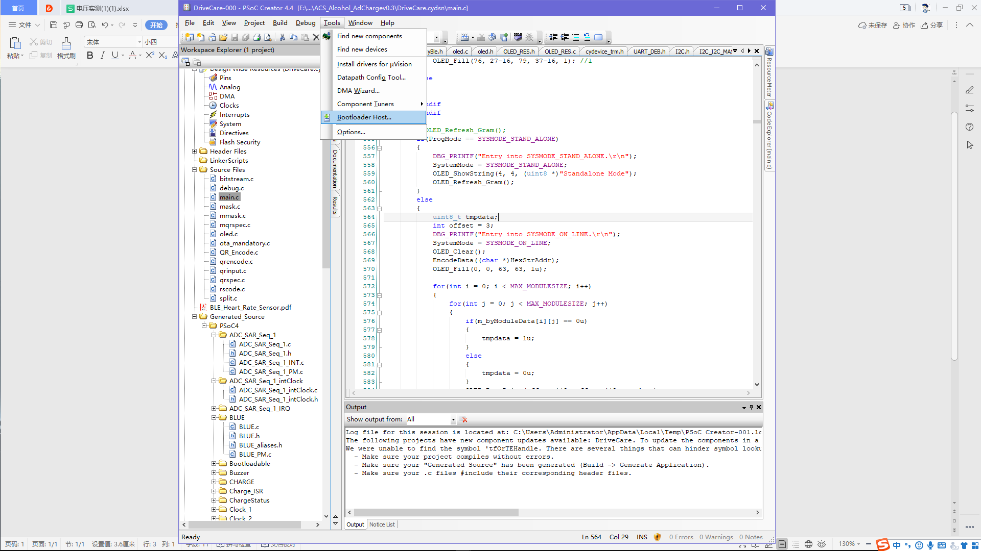

1. Power on a DriveCare unit and connect it to a PC using a TTL-USB cable. Use a general serial port tool to send command *\*08010A0B0C0D#* to DriveCare, using baud rate：115200. This step allows DriveCare entering OTA upgrading status.
2. 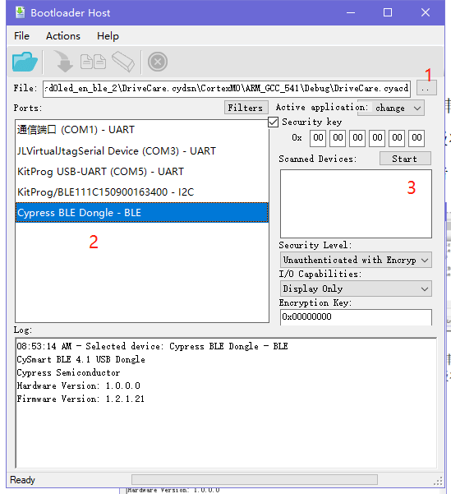Insert the dongle to a USB port.

1、Select the f/w file.

2、Select the type of dongle inserted.

3、Click *Start*

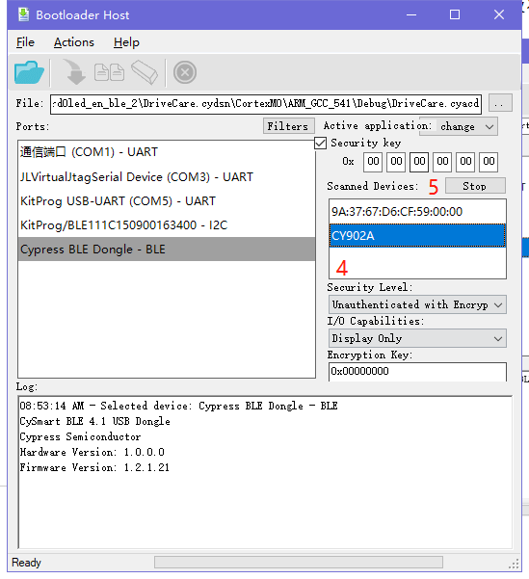

1. Select the Bluetooth name (CY902) found。
2. Click *stop*
3. Click “*download*” icon and then wait until

completion of programming.

1. Note：

Do not remove the dongle from PC

or power off the unit before completion

of programming. Otherwise the unit must be

returned to the manufacturer.

